SHLOK ANAND

23070521142

SQL Aggregate Functions in SQL*Plus (Oracle) & MySQL

Aggregate functions perform calculations on multiple rows and return a **single** value. These functions are useful in **summarizing** data, such as totals, averages, counts, etc.

Below are detailed examples covering all aggregate functions in **SQL*Plus (Oracle)** and

**MySQL**.

# Aggregate Functions in SQL*Plus (Oracle)

## SUM() – Total of a Column

SELECT SUM(salary) AS total_salary FROM employees; -- Total salary of all employees

SELECT department_id, SUM(salary) FROM employees GROUP BY department_id; -- Total salary per department

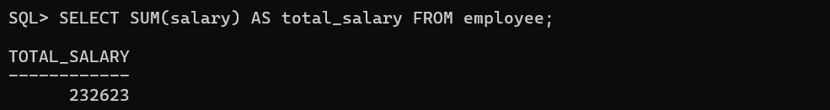

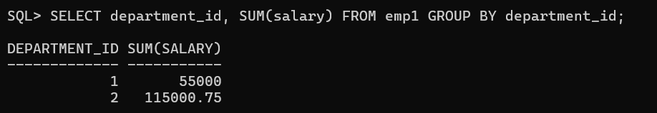

## AVG() – Average of a Column

SELECT AVG(salary) AS avg_salary FROM employees; -- Average salary SELECT department_id, AVG(salary) FROM employees GROUP BY department_id; -- Average salary per department

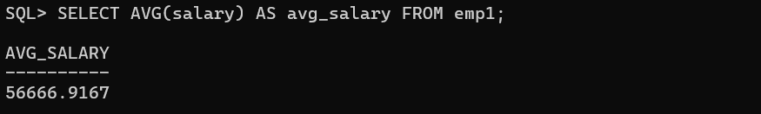

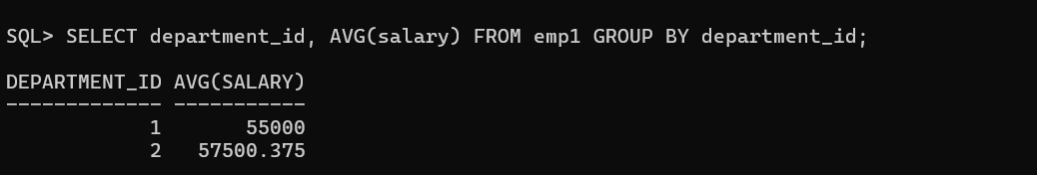

## COUNT() – Counting Rows

SELECT COUNT(*) FROM employees; -- Total number of employees

SELECT COUNT(employee_id) FROM employees WHERE department_id = 10; -- Count employees in department 10

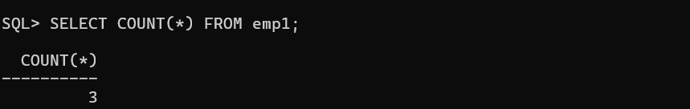

## MAX() – Maximum Value

SELECT MAX(salary) FROM employees; -- Highest salary in the company SELECT department_id, MAX(salary) FROM employees GROUP BY department_id; -- Highest salary per department

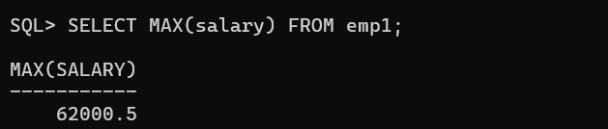

## MIN() – Minimum Value

SELECT MIN(salary) FROM employees; -- Lowest salary in the company SELECT department_id, MIN(salary) FROM employees GROUP BY department_id; -- Lowest salary per department

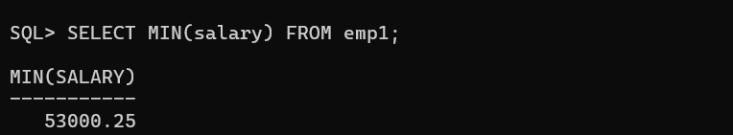

## 

## MEDIAN() – Median Value (Oracle-Only)

SELECT MEDIAN(salary) FROM employees; -- Median salary of all employees

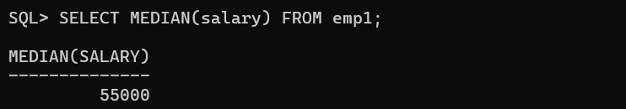

## STDDEV() – Standard Deviation

SELECT STDDEV(salary) FROM employees; -- Standard deviation of salaries

SELECT department_id, STDDEV(salary) FROM employees GROUP BY department_id; -- Std deviation per department

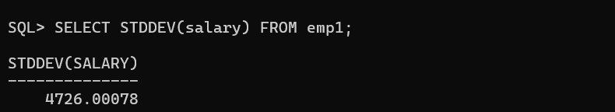

## VARIANCE() – Variance of a Column

SELECT VARIANCE(salary) FROM employees; -- Variance of salaries

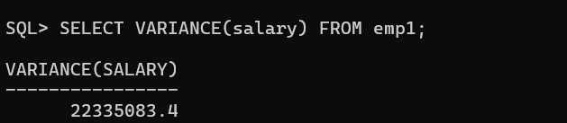

## GROUP BY with Aggregate Functions

SELECT department_id, COUNT(*), AVG(salary), MAX(salary), MIN(salary) FROM employees

GROUP BY department_id; -- Aggregate calculations per department

